**Objectives:**

* Define and understand the software development lifecycle in the context of the 3D TicTacToe programming project (Module B.5).
* Apply the lifecycle to anticipate and plan future activities that will be required to bring the 3D TicTacToe programming project to conclusion.

**Level 1: Defining The Software Development Lifecycle Phases**

The software development lifecycle involves the following distinct phases.

1. problem definition
2. analysis & design
3. writing code
4. testing
5. implementation & delivery
6. maintenance

For each of the above phases:

1. Research the definition in the context of software development

Problem definition: An idea is proposed to a software development team. They research and plan for what resources are needed to complete the project; like how much money and time are given. In addition, the team consults with the client to find out what the end product should be. For example, what functions are to be included in the end product.

Analysis and Design: The team that looks at the requirements for the end product and begin thinking of ways to execute the project. For example, the development team can partition the project into smaller components such as classes and objects.

Writing code: The team executes the plan and begins development of the product.

Testing: The product is nearly finished, the software undergoes vigorous testing to discover any bugs that may exist. This testing may include consumers who are willing to give feedback whenever they find a bug or want feature to be included in the product top make it better.

Implementation and Delivery: After large amounts of testing, the product is finalized and ready to be commercialized or presented to the client.

Maintenance: After the product is shipped, the team can continue to add more features and optimizations and push them through an update. Also bugs may appear after a while from the product’s release date, so the team can identify the problem and redo the cycle.

1. Explain how it applies (or will apply) to the 3D Tic-Tac Toe project.

The software development cycle applies to our 3D Tic-Tac Toe project because our client, Mr. Nestor came to us with an idea, which was the game 3D Tic-Tac Toe, the requirements and expectations of the end product was given. After that, we went into the analysis and design phase where we decided to partition the project by giving each pair of group members a component to develop. Currently, the team is in the writing code phase and each group member is working on their own part of the program.

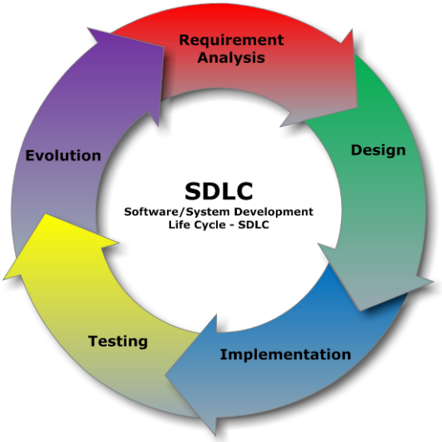

**Level 2: Understanding The Software Development Lifecycle Phases**

Explain how the problem definition phase could have been improved to produce a clearer specification that would result in a richer set of application features.

The team could have asked more specific questions from the client, Mr. Nestor. For example, we could have asked how the GUI should look like. In addition, a great way to communicate with the client would be to arrange an interview between Mr. Nestor and the team.

Consider the use of the following techniques: dialogue, questionnaires, surveys, and research.

As a team, develop a tool / technique that will help to improve your 3D TicTacToe specification.

Think about what you did regarding analysis and design for the 3D TicTacToe project.

What was good about the process you followed?

What was bad about the process and what could be done to improve the process?

Think about what will be required for testing your 3D TicTacToe project code.

List some major things that you will have to test.

Research about what a software test plan looks like

Create a test plan for your 3D TicTacToe project code

For the delivery phase, think about what will be required to host a small 3D TicTacToe tournament for the Grade 11 Students.

How will the tournament be organized?

The competitors will be arranged into a tree diagram, it will be done in a random fashion.

How will they load and run your TicTacToe application?

The competitors will be instructed to download and import the project file

How will you deal with problems and bug reports?

**Level 3: Applying The Software Development Lifecycle Phases**

t.b.d

**Curriculum Notes**

B4.1 describe the phases (i.e., problem definition,

analysis, design, writing code, testing, implementation,

maintenance), milestones (e.g., date

of completion of program specification), and products

(e.g., specification, flow chart, program,

documentation, bug reports) of a software development

life cycle;

B4.3 use project management tools (e.g., Gantt

chart, critical path diagram, PERT chart) to show

tasks and milestones in a teacher-led project;

B4.6 communicate information about the status

of a project (e.g., milestones, work completed,

work outstanding) effectively in writing

throughout the project.

Grade